CREATE TABLE `boardgames` (

`titleBG` char(40) NOT NULL,

`countryOfOrigin` char(40) DEFAULT NULL,

`category` char(20) DEFAULT NULL,

`publisherBG` char(50) NOT NULL,

PRIMARY KEY (`titleBG`,`publisherBG`))

CREATE TABLE `marvelmovies` (

`titleM` char(50) NOT NULL,

`releaseDateM` int NOT NULL,

`leadActor` char(25) DEFAULT NULL,

PRIMARY KEY (`titleM`,`releaseDateM`))

CREATE TABLE `participants` (

`highScore` int DEFAULT NULL,

`name` char(25) NOT NULL,

`password` char(10) NOT NULL,

`admin` tinyint DEFAULT '0',

PRIMARY KEY (`name`,`password`))

CREATE TABLE `videogames` (

`titleVG` char(50) NOT NULL,

`releaseDateVG` int DEFAULT NULL,

`genreVG` char(25) DEFAULT NULL,

`publisherVG` char(50) NOT NULL,

PRIMARY KEY (`titleVG`,`publisherVG`))



Figure : This is the script which allows the admin to add new information to MarvelMovies



Figure : This is the script which allows the admin to add new information to BoardGames

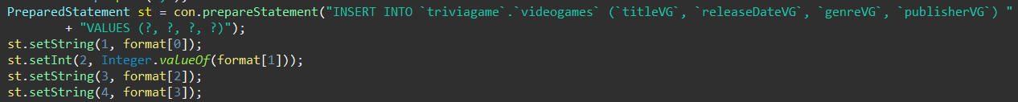

Figure : This is the script which allows the admin to add new information to VideoGames

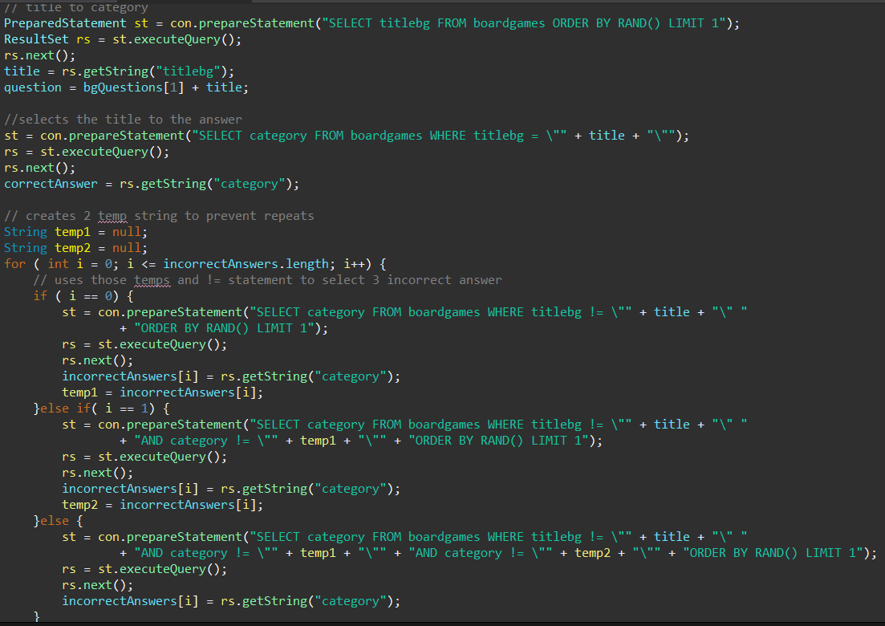

Figure : This is an example of populating a question, then grabbing incorrect answers and a correct answer

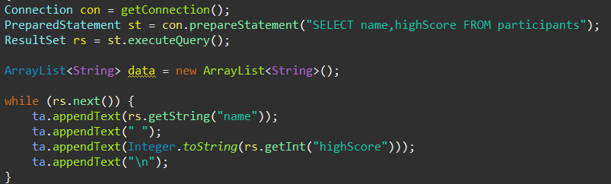

Figure : Populating HighScores



Figure : Part of the code which allows the user to login



Figure : Part of the code which allows the user to create a login



Figure : Allows the user to save their highscore